EAGLE ONE
Top-Rated Water Tank Suppliers in Dubai
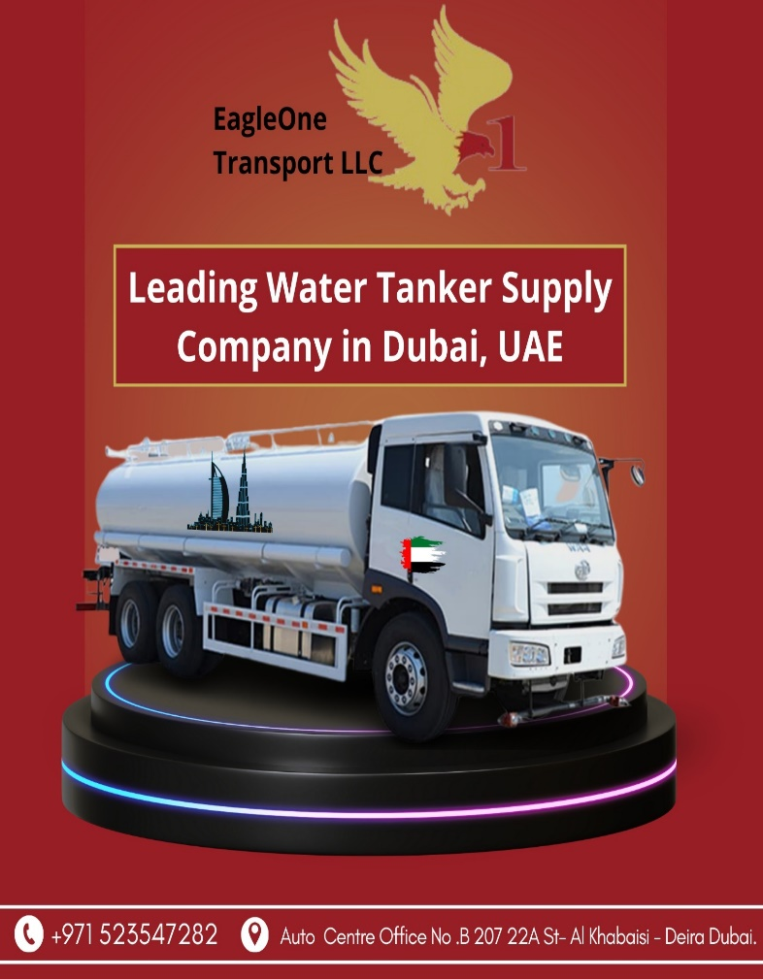
Do you need Water tank supply service, we are providing you with quality assured water, and pumping it directly into your
System? Our water tanker fleet is ready to make bulk deliveries across the UAE. Each tanker is equipped with a high volume
Our wide range services include:
1. Swimming Pool Water Supply
2. Sweet Water Tanker Supply
3. Salt Water Tanker Supply
4. TSE (Irrigation) Water Tanker
5. Drinking Water Transport
We proudly serve areas across Dubai including, like Deira, Al Barsha South, JVC, JVT, Down town Dubai, Dubai Marina,
Palm Jumeriah , Dubai international city, Business Bay, Dubai Silicon Oasis, Dubai Sports City and Dubai Investment Park.
Eagle One Transport LLC is here to ensure that all your water needs are met quickly and reliably.

COMPANY INFORMATION

Name: Eagle One

Office Location:
Auto Centre Office No .B 207 22A St- Al Khabaisi - Deira Dubai.
Phone: (04) 449 5034

Call: +971 523547282
Email: info@eagleone1.com
Website: https://www.eagleone1.com/

Social Links:
https://www.facebook.com/EagleOneTransportLLC
https://www.youtube.com/@EagleOneTransportLLC
https://www.linkedin.com/company/eagleone-transport-llc/

